Stress-controlled shear flow alignment of collagen type I hydrogel systems

Lens M. Dedroog, Olivier Deschaume, Christian J. Garcia Abrego, Erin Koos, Yovan de Coene, Anja Vananroye, Wim Thielemans, Carmen Bartic and Minne P. Lettinga*

L. M. Dedroog, Olivier Deschaume, Christian J. Garcia Abrego and Carmen Bartic

Soft Matter Physics and Biophysics Unit, Department of Physics and Astronomy, KU Leuven, 3001 Leuven, Belgium

E. Koos and A. Vananroye

Soft Matter, Rheology and Technology, Department of Chemical Engineering, KU Leuven, 3001 Leuven, Belgium

Y. de Coene

Molecular Imaging and Photonics Unit, Department of Chemistry, KU Leuven, 3001 Leuven, Belgium

W. Thielemans

Sustainable Materials Lab Research Group, Department of Chemical Engineering, KU Leuven, Campus Kulak Kortrijk, 8500 Kortrijk, Belgium

M. P. Lettinga

Soft Matter Physics and Biophysics Unit, Department of Physics and Astronomy, KU Leuven, 3001 Leuven, Belgium

Biological Information Processing IB-4, Forschungszentrum Jülich, 52425 Jülich, Germany.

E-mail: Pavlik.Lettinga@kuleuven.be

Abstract

Disease research and drug screening platforms require *in vitro* model systems with cellular cues resembling those of natural tissues. Fibrillar alignment, occurring naturally in extracellular matrices, is one of the crucial attributes in tissue development. Obtaining fiber alignment in 3D, *in vitro* remains an important challenge due to non-linear material characteristics. Here, we report a cell-compatible, shear stress-based method allowing to obtain 3D homogeneously aligned fibrillar collagen hydrogels. Controlling the shear-stress during gelation results in low strain rates, with negligible effects on the viability of embedded SH-SY5Y cells. Our approach offers reproducibility and tunability through a paradigm shift: The shear-stress initiation moment, being the critical optimization parameter in the process, is related to the modulus of the developing gel, whereas state of the art methods often rely on a predefined time to initiate the alignment procedure. After curing, the induced 3D alignment is maintained after the release of stress, with a linear relation between the total acquired strain and the fiber alignment. This method is generally applicable to 3D fibrillar materials and stress/pressure-controlled setups, making it a valuable addition to the fast-growing field of tissue engineering.

Keywords: collagen, alignment, anisotropy, hydrogels, rheology.

1. Introduction

Tissue engineering is a rapidly growing domain in the field of biomedical engineering with the central aim of functionally mimicking living tissues. Recently, there is a multidisciplinary effort towards understanding how material properties are guiding cell responses in 3D engineered tissues [1][2]. Mechanical gradients, multiscale, structural complexity and viscoelastic behavior of extracellular matrices (ECMs) are involved in healthy tissue formation and function [3–5] as well as in pathological developments such as tumorigenicity and metastases [6–8]. Physical cues are applied to the enveloped cells through the highly organized, multiscale fibrillar hydrogel scaffold of the ECM [9][10]. In ECM engineering, the goal is thus to develop a 3D hydrogel system that fully mimics the tissue-specific *in vivo* environment [10][2]. Commonly investigated candidates are the naturally derived hydrogel systems collagen and fibrin due to their tissue ubiquity, inherent biocompatibility and degradability for a wide range of cell types [11]. Collagen-based systems are especially of interest due to the possibility to measure morphological parameters of the 3D hydrogel network (such as fiber size, shape, orientation and pore size) in a label-free way by confocal reflection microscopy [12] or second harmonic generation (SHG) [13]. SHG is particularly interesting for imaging dense, thicker biological samples [14] since it is based on the scattering of near infrared (NIR) photons. It can moreover be used to extract orientational and symmetry parameters [15].

During embryogenesis, collagen fibrillar matrices form 3D aligned (anisotropic) structures in certain specialized tissues, including cardiac tissue [16], muscle [17], cartilage [18] and the dermis [19]. Over the last decade, reproducing this *in vivo* alignment of the 3D fibrillar matrix *in vitro* was proven to be important to obtain a higher transferability between *in vivo* and *in vitro* cellular phenotypes [20–23], which is crucial for the development of new therapeutic strategies [24][25]. For example, ECM alignment guides neuronal polarization [25][22][26] and directs neurite motility [27], which are both critical aspects in neurogenesis [28]. Also, tendon remodeling capability is enhanced in 3D aligned ECMs [20], ECM anisotropy induces native myocardium development *in vitro* [21] and anisotropic cues were shown to guide the formation of bone collagenous ECM microstructure [23]. Furthermore, matrix alignment has a direct clinical impact, since studies showed the pathological relevance of incorporating ECM alignment in tumor-tissue invasion models [24].

Inducing homogeneous fibrillar matrix alignment in 3D cell-containing matrices over significant length scales is not trivial [29]. Various methods have been proposed for directing the self-assembly of collagen fibrillar hydrogels, either applying a constant strain rate during gelation [30–34] or a constant strain after partial or complete gelation [35–39], resulting in fibers orienting along the direction of the applied strain or strain rate.

Approaches employing a constant are commonly used in extrusion setups (*e.g.* bioprinters) [32–34]. Furthermore, a constant strain rate has also been achieved by inducing local migration of embedded magnetic beads [30]. More recently, Marangoni flow was shown to promote collagen alignment near the edges of evaporating droplets, capable of directing the elongation direction in smooth muscle cells [31]. However, in these studies the effect on cellular behavior is evaluated based on the presence or absence of alignment rather than over a range of different alignment degrees. A possible reason for the absence of tuneability is that applying a constant strain rate to a gel will lead to ruptures of the underlying network and eventually to heterogeneity in concentration as well as in alignment [40][41]. In contrast, studies utilizing a constant have achieved control over the induced 3D alignment by means of soft lithography [35]. Here, varying degrees of alignment are obtained by controlled stretching of a fully cured confined collagen network. The resulting aligned collagen matrices were shown to promote vascular tissue formation [35], the *in vitro* reconstruction of hippocampal neuronal circuits [36] and even to direct the global migration of cancerous stem cells [8]. A limiting factor in these systems is, however, that the external stress provided by the confinement of the network, cannot be removed without loss of alignment, which may hamper potential applications. Consequently, tissue engineering applications demand novel approaches that allow tuning fiber alignment in 3D networks, resulting in homogeneous and reproducible cell-laden *in vitro* model systems without the need for external stresses to sustain alignment.

In this paper we introduce a new methodology resulting in fibrillar networks with self-supported, highly reproducible alignment and a homogeneous fiber density. This is achieved by subjecting the solidifying system, at a well-defined initiation point, to a constant shear stress (), which is high enough to temporarily initiate flow during gelation, while remaining sufficiently low to guarantee that cessation of flow occurs due to further solidification. This cessation ensures the persistence of the induced alignment, which we characterize using SHG microscopy.

We describe first how the new protocol yields a material with well-controlled rheological properties, such as the induced strain (), based on the process parameters. We then demonstrate how these properties are related to the alignment in the sample. Subsequently, the limitations of the technique are discussed, together with the impact of gelation temperature (37 ◦C or 27 ◦C).

**2. Materials and methods**

**2.1 Stress controlled shear flow approach**

In our method, a stress is applied using a rheometer with a plate-plate geometry at a well-defined time during gelation, which we refer to as the initiation point. The applied stress is kept constant over a duration exceeding the time needed to complete the solidification process of the hydrogel.

The system will per definition flow when the applied stress exceeds the yield stress () of the material (). When is much higher than the yield stress, , then the system will continuously flow and break (**Figure 1.b**), which will induce heterogeneities in fiber density. When is much smaller than the yield stress of the material, so when , then will induce deformation, , and alignment as long as it is applied, but a complete recoil will occur upon removing the stress, meaning that there is no final induced deformation and no effective fiber alignment (**Figure 1.b**).

In order to produce a network with a homogeneous fiber density where alignment is retained, the initiation point has to be found between these two extremes, such thatis slightly higher than , . In this case, the system will initially flow, but flow will cease when , as increases over time during solidification. The sample will be able to partially recoil to a final , but the stability and homogeneity in terms of alignment and fiber density of the 3D hydrogel will be retained (**Figure 1.b**).

The two essential questions that need to be addressed in order to obtain a sufficiently high are therefore: (1) how to determine the optimal initiation point to apply the stress and (2) which stress magnitude, is needed to obtain a satisfactory . Determining the optimal initiation point to start shearing is not straightforward because gelation is a non-linear process, intrinsically prone to fluctuations due to environmental changes (*e.g.* humidity, temperature, etc.) and/or small changes in concentration [42][43] (**Figure 1.a**). Applyingat a predefined moment in time therefore results in limited predictability of the obtained deformation, as the yield stress, varies between different samples. To solve this issue, the initiation point needs to be identified based on a parameter that characterizes the material state, for instance the shear modulus () at a given time point, which is a direct measure for [44]. To this end, a stress-controlled rheometer is employed that can apply a well-defined and also measure *in situ* as a function of time (see section 2.3). In this way, the initiation point, whereis applied, is the moment at which reaches a pre-defined value (). Thus, we have two control parameters, namely and

can be decomposed into the storage and loss moduli, respectively and . Upon increasing the temperature, both moduli increase over time, with increasing at a faster rate than . Hence, while initially, these moduli will become equal at a specific moment in time (). At this point the system has a non-zero , which corresponds to a specific stiffness (). Therefore, to reduce the window of to be probed, a logical choice for lies in the region where a non-zero exists, so that . As mentioned before, the material will flow when , and stop flowing when the yield stress exceeds the applied stress (*e.g.,* ). As a result, when using an appropriate and , rupture will be prevented and a finite will be obtained. By varying and keeping fixed, one can tune the degree of deformation applied to the hydrogel. In this work, we found the relation between , controlled by , and the resulting induced fiber alignment, which was evaluated using second harmonic generation (SHG) microscopy.

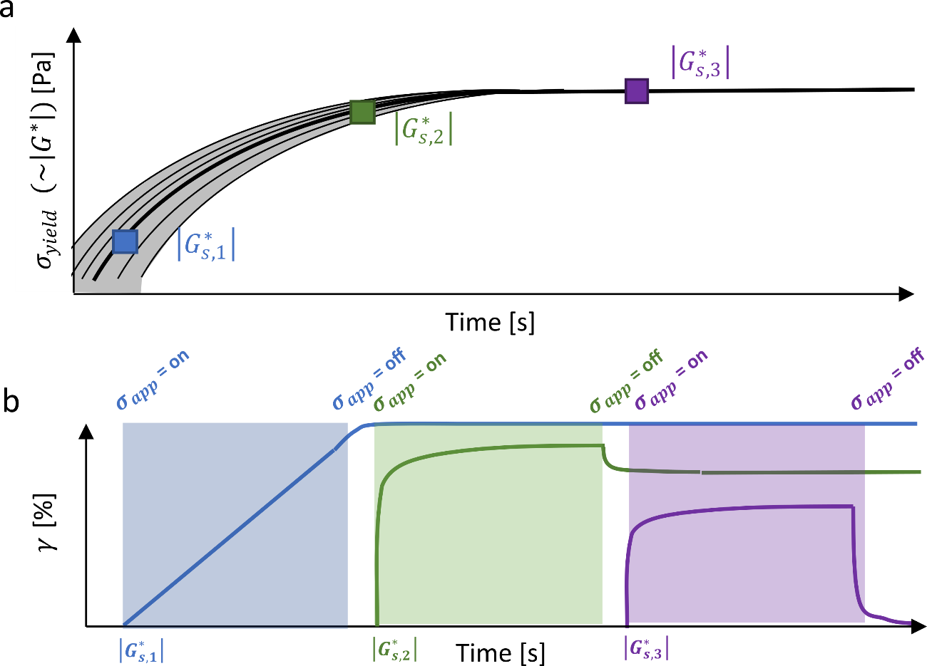

**Figure 1.** **Illustration of the initiation time importance for the stress-controlled shear-flow alignment procedure.** (a) Schematic illustration of the variation that one would observe in network formation between different samples. Here the y-axis indicates the stiffness () which is proportional to the yield stress (). (b) For each initiation point the applied stress is illustrated (dotted line) with its corresponding strain response (thick line).

**2.2 Sample preparation**

All samples were made using FluoroBrite™ DMEM (Gibco™, Thermo Fisher Scientific), supplemented with the appropriate amount of non-essential amino acids (NEAA) (Gibco™, Thermo Fisher Scientific), 10 % fetal bovine serum (FBS) (Gibco™, Thermo Fisher Scientific) and 100 units/ml penicillin-streptomycin (PEN-STREP) (Gibco™, Thermo Fisher Scientific), this is referred to in the following sections as ‘physiological buffer’.For all experiments, acid-solubilized bovine collagen type I (Sigma-Aldrich) at a concentration of 6.0 mg/ml solution was used. The pH was adjusted to 7.4 0.1 using NaOH (Fisher Scientific). Hereafter, the solution was diluted using the physiological buffer to reach a final collagen concentration of 1.0 mg/ml.

**2.3 Rheology**

The rheological experiments were performed with a stress-controlled rheometer (Anton Paar MCR501, Austria) with a torque limit of 0.02 Nm, using a P-PTD Peltier system with solvent plate insert and a 25 mm diameter steel plate top geometry with a gap size of 500 µm. To prevent solvent evaporation, a H-PTD hood with evaporation blocker was utilized in combination with the addition of mineral oil (Sigma-Aldrich) around the sample. A full description of the rheological experimental procedures is given below:

**Time sweep**:First, the gelation kinetics were determined by measuring the dynamic moduli - shear modulus (), storage modulus () and loss modulus () - throughout time. For this purpose, an oscillatory time sweep was performed with a constant frequency of 5.0 rad/s and a strain () of 1.0 % for 45 minutes to determine the time needed for the samples to fully cure.

**Strain sweep:** To determine the linear viscoelastic regime an oscillatory strain sweep was conducted in which was varied over a range of 0.1-100.0 % with a frequency of 5.0 rad/s. As observed in the supplementary **Figure S1**, strains below 2.0 % fall within the linear regime.

**Shear flow protocol:** The first step in our alignment approach consisted out of measuring the increase of the dynamic modulus () throughout time. When a predetermined value was reached () a rotational stress () was applied to the material. This stress was kept constant over a time period exceeding the gelation time (26 minutes), determined by the time sweep experiments (**Figure S2**). Lastly, the stress was released and the material left to relax for another 15 minutes on the rheometer before removing the sample with a spatula and storing it in physiological buffer at 37 ◦C for up to three days after preparation.

**Frequency sweep:** To determine the time dependent viscoelastic behavior, the dynamic moduli were measured over a frequency range of 0.1-100 rad/s using an oscillatory of 1.0 % (**Figure S3**). For samples solidified at 37 ◦C the moduli varied between 30-10 Pa for the storage moduli and 5.0-2.0 Pa for the loss moduli. Solidification at 27 ◦C caused the moduli to be significantly higher with the storage moduli ranging from 70 Pa to 24 Pa and the loss moduli from 12 to 3.0 Pa.

**2.4 Second harmonic generation (SHG)**

SHG images were obtained using an Olympus BX61 WI-1200-M system. Laser excitation was delivered by an insight DS+ laser system (Spectra-Physics) producing a horizontally polarized beam with a frequency of 80 MHz and a 120 fs pulse width. Laser power was modulated using an achromatic half-wave plate and a Glan-Taylor polarizer, producing a vertically polarized beam. Subsequently, a quarter-wave plate at 45° was used to produce a right-handed circularly polarized beam entering the microscope. A laser power of 32 mW was used at the sample location. The laser beam was set at an excitation wavelength of 900 nm, and focused onto the sample using a 40× water immersion objective (Nikon CFI APO NIR, 0.80 NA, 3.5 WD). SHG was detected both in the forward and backward directions, in a non-descanned geometry, with Hamamatsu R3896 photomultiplier tubes. Both paths used a filter cube with a 470 LPXR dichroic mirror for two-photon excited fluorescence and 450/7 bandpass filter (Chroma) for SHG. The acquired images had a resolution of 512x512 pixels, with an image capture speed of 40 m/s. For all Z-stacks, a Z-step of 15 m was chosen.

**2.5 Quantification of fibrillar alignment**

To obtain a quantitative understanding of anisotropy, an order parameter (S) was determined, defined as: Here, S is a dimensionless unit that varies between zero for a completely random orientation, and one for a fully ordered phase. A fully ordered phase means that all visualized fibers run parallel along the direction of the local director (). The local director was calculated as the most occurring angle of the fiber distribution, using the following equation:

,

with, the angle between the fiberand the x-axis. Hereafter, the distribution was normalized by placing the director in the middle. Following this step, the distribution was fitted using an exponential function [45]:

Here and indicate the fitting parameters for the model. With this fit, the 2D order parameter for each plane was calculated:

Next, the average over the entire depth was taken. To relate this parameter to the macroscopic the radial profile had to be corrected since a plate-plate geometry was used. This was done by applying a correction factor:

with , the radius of the cylindrical sample. To relate this to a single indicative parameter per sample, the profile was integrated over a specific radial plane and normalized. In this way, for each sample a comparable average order parameter () was obtained:

Furthermore, depends on the radial interval () over which it is calculated (**Figure S4**). All analyses were performed using MATLAB® 2021a.

**2.6 Cell culturing, viability and morphology**

SH-SY5Y cells (a human derived neuroblastoma cell line) with and without GFP-tag, were cultured for three days under physiological conditions (37 ◦C and 5 % CO2) up to 80 % confluency. The cells were then dissociated using Versene (Gibco™, Thermo Fisher Scientific) and resuspended in phosphate buffered saline (PBS) (Gibco™, Thermo Fisher Scientific). The neutralized collagen monomer solution was then mixed with an aliquot of the cell suspension to reach a final concentration of approximately 105 cells/ml.

After applying the stress-controlled shearing procedure on the cell-laden hydrogels, both the viability and morphology was assessed via confocal microscopy. For the purpose of determining the viability, SH-SY5Y cells (without GFP-tag) embedded in the collagen hydrogels were fluorescently labelled with Calcein AM (Sigma-Aldrich, USA) for live cells while the dead cells were stained with Nuclear Blue™ DCS1 (ATT Bioquest, CA, USA) according to manufacturer instructions. Briefly, the medium was gently removed from the samples and replaced with PBS for 10 min. Thereafter, samples were stained with 2 μM Calcein AM and 4 μM Nuclear Blue in PBS at 37 °C. After 30 min incubation, the staining solution was removed and replaced with PBS prior to imaging. Cell imaging was performed in three different areas of the hydrogels using an inverted confocal microscope LSM 880 (Zeiss, Oberkochen, Germany) with a 10× objective lens. z-stack images were collected for the cells in the hydrogels with a size of 1400 μm × 1400 μm × 200 μm.

The morphology of the embedded, GFP-tagged SH-SY5Y cells was determined using a SP8 Dive (Leica Microsystems, Wetzlar, Germany) confocal microscope with a 10× objective lens. To determine the azimuth direction of the collagen sample, a single z-plane with a size of 1550 μm × 1550 μm was measured using a pinhole size of 186.0 μm. This allowed visualizing the sample edge using collagen autofluorescence. Next, z-stack images were collected for the cells in the hydrogels with a size of 358 μm × 358 μm × 50 μm, using a pinhole size of 41.4 μm.

**2.7 Statistical Analysis**

For each condition a minimum of three areas was taken into account for statistical analysis. The statistical significance between different conditions was determined using a student’s two-sample *t*-test with a significance level *𝛼* = 0.05. All analyzes were performed using MATLAB® 2021a.

3. Results and discussion

3.1. Tuning the procedure to obtain shear stress-controlled deformation

Reproducibility is crucial for the development of commercial drug screening and/or therapeutic platforms. To produce aligned cellular matrices in a reproducible manner using a shear flow approach, it is essential to accurately identify the initiation point at which the sample should be deformed. As discussed in the introduction, most shear flow procedures choose a predefined time, after starting the gelation (), for this purpose. The problem with this approach is that gelation kinetics are prone to fluctuations [42][43]. The issue is highlighted in our time sweep experiments (**Figure 2.b** and **Figure S2**) where we see a clear shift of curves along the time axis, indicating that is not a predictable parameter for the system behavior. As such it is vital to relate the initiation point of the stress to the stiffness of the solidifying material, as opposed to , thus eliminating the temporal variations in (and thus ) between samples.

This work explores a paradigm shift where we apply a predefined rotational stress () at the time , where reaches a preset value (). This will result in a shear flow, thus straining the material. The applied stress is removed (*i.e.,* = 0.0 Pa) after the system has fully cured, in this case after 26 minutes, and the remaining strain after partial recoil is measured, referred to as (see **Figure 3.a**). A production cycle is successful when the system remains stable, yielding a sample which acquired a strain , and therefore fiber alignment, sufficiently high for the desired application. To this end, optimization of both and is required. This is done iteratively as described in **Figure 4**.

Initially, a fixed and are chosen and the procedure is initiated. These initial values are system and batch-dependent. To minimize the parameter space, we choose the initial value of to be close to the cross-over modulus (**Figure 2.a)**, preferably above the detection limit of the rheometer. In the case of gels prepared with 1 mg/ml collagen type-I, we find that Pa at 27 ◦C and Pa at 37 ◦C. The error bar in is mainly due to the fact that the effective torque for this measurement approaches the torque limit of the rheometer ( Pa). For a 1 mg/ml collagen hydrogel, we choose (1.35 Pa) and Pa as starting values. When the sample ruptures and flows (*i.e.,* breaks), given the chosen and , the procedure is repeated with a lower and/or a higher . When a stable strained gel is formed but is too low for the desired application, the procedure is repeated with a higher and/or a lower .

To demonstrate the tunability of , using as a control parameter, was varied while keeping constant. The value of was determined by the optimization process described above, resulting in values of 1.5 and 3.0 Pa for samples solidified at 27 and 37 ◦C respectively. In this manner, a broad range of was obtained (between 0.0 and 127.0 %) for samples solidified at 27 ◦C, as displayed in **Figure 3.a**. The range of for samples solidified at 37 ◦C was more limited with a maximum of 73 % (**Figure S3**). Due to the higher being obtained all further results are obtained using a curing temperature of 27 ◦C unless specified otherwise.

Equivalently to , depending on the value of , different strain rates are exerted onto the material when applying a constant stress. The experimentally obtained strain rates were fitted to a power-law model (), where the fitting parameter was found to be a constant (-0.91 0.19) while the zero-strain rate () depends on , see (**Figure 3.b**). and decrease both non-linearly upon increasing (**Figure 3.c**). Slight variations in prevent the exact reproducibility of the resulting strain, , as is close to the torque limit and strongly depends on . However, the observed relationship between and is significantly less variable than the relationship between and , as can be appreciated when comparing **Figure 3.c** and **Figure 3.d**. This highlights the fact that knowledge of the initial material stiffness is paramount for a reproducible stress-controlled alignment.

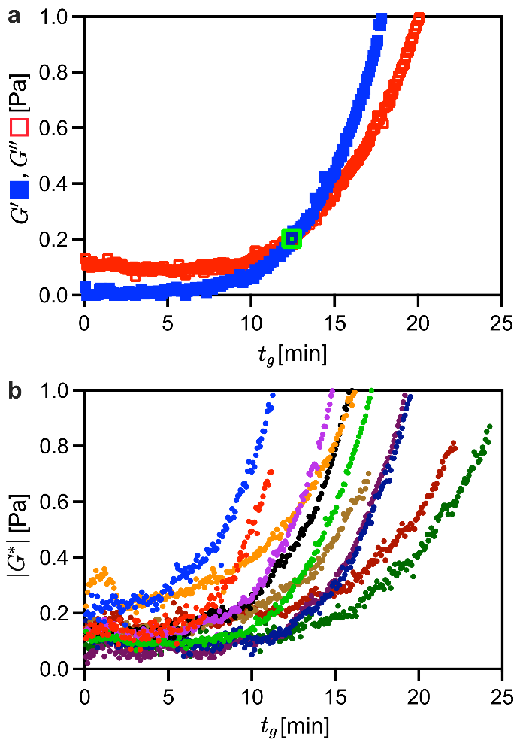

Figure 2. Experimental data on the time sweep behavior of collagen type I. (a) Representation of the loss and storage moduli in time for collagen type I gelation at 27 ◦C, the cross-over () is indicated with a green square. (b) Evolution of the complex moduli in time for eleven samples exposed to 27 ◦C.

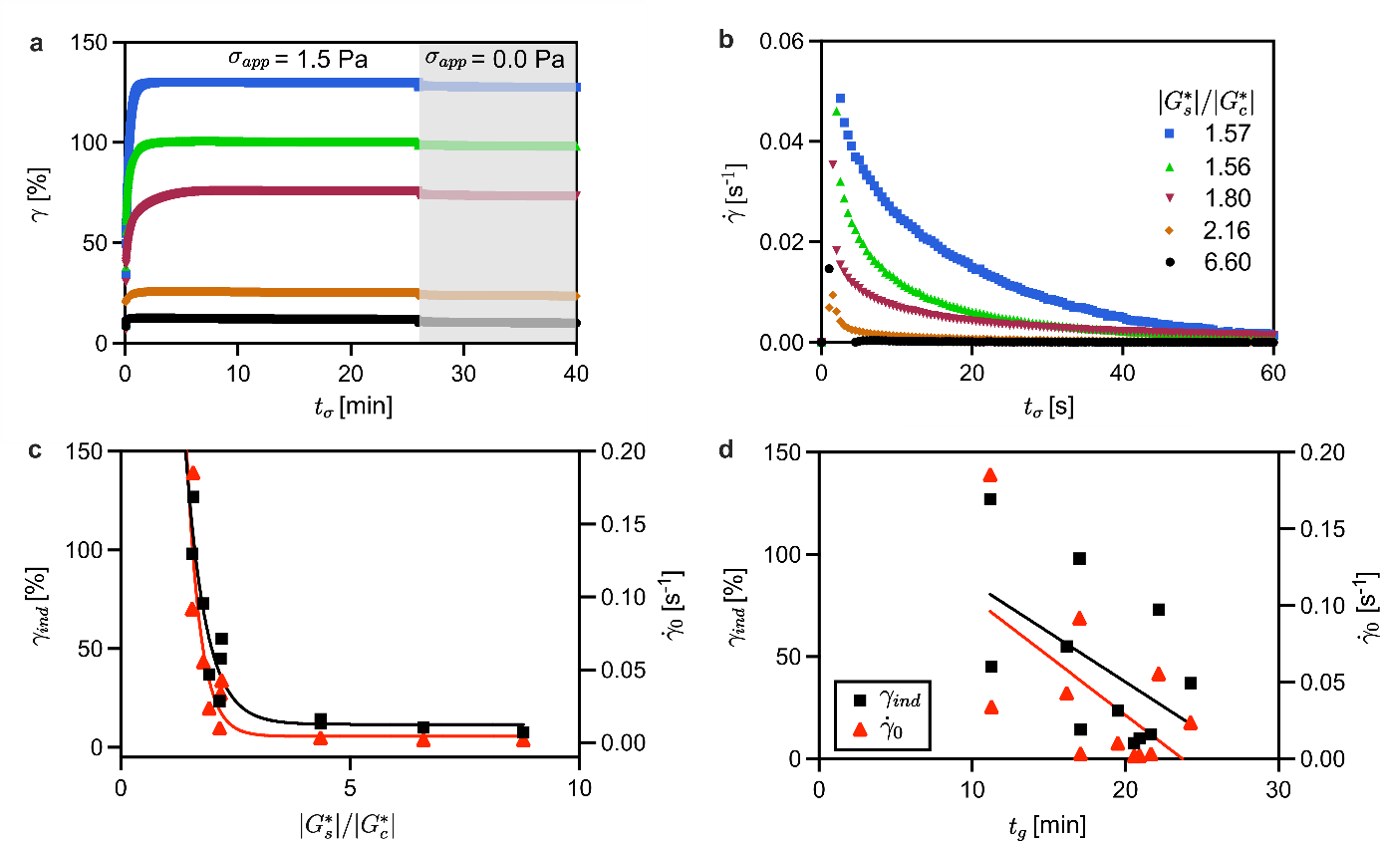

Figure 3. Relation between the macroscopic rheological properties and the initiation point (). (a) Strain profiles for various , dashed line and shaded area visualize the presence or absence of a non-zero applied stress (). (b) Strain rate behavior over time, after stress has been applied, for different values of . Legend from (b) also applies to (a). Comparison between (c) stiffness- or (d) time-controlled stress initiation, for the induced strain () and the initial shear-magnitude (). In (c) and (d), error bars representing the standard error are smaller than the symbol size for (c) and (d). Solid lines in (c) and (d) are added to guide the eye. The applied rotational stress for all these samples was 1.5 Pa. All samples were prepared at a temperature of 27 ◦C.

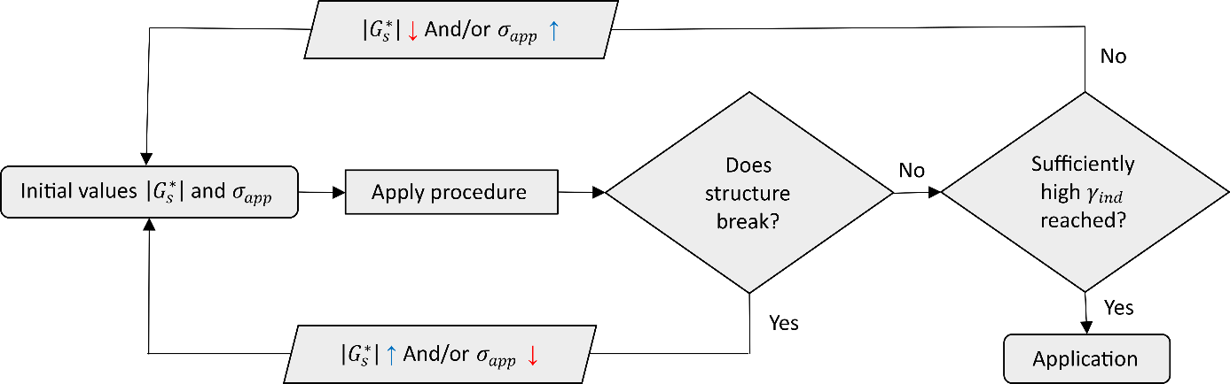

Figure 4. Optimization flow scheme of the shear-stress controlled approach. The target acquired strain () is obtained by tuning the initiation point () and the magnitude of the applied rotational stress () in an iterative manner.

3.2. Characterizing the resulting fibrillar alignment

Apart from reproducibility, the other key point of this work is to relate the measured macroscopic rheological properties (*e.g.,*  and) to the degree of induced orientational ordering, as quantified by the order parameter () (see section 2.4 for more details). Using SHG microscopy, the 3D order distributions of samples aligned with different values were characterized (**Figure 5.a-d**).  increases with the distance from the center of the sample (**Figure 5.e**), due to the radial dependence of the strain exerted by the rotational stress for the plate-plate geometry used here. In contrast, the ordering along the gel height (indicated as ) appears more homogeneous in the bulk, though it decreases slightly towards the sample edges due to interfacial effects (**Figure 5.c and d**). Moreover, extensive visual scanning of the sample along all dimensions shows that the fiber density is homogeneous meaning no cluster formation and/or fracture occurred. An average order parameter () was calculated for each sample, as described in the materials and methods section. The relation between this microscopic parameter and the macroscopically induced strain follows a linear trend (blue curve in Figure 5.g), while its relation with the strain rate magnitude is non-linear (red curve in Figure 5.g). Furthermore, this parameter has a well-defined non-linear relation with (Figure 5.f), indicating that by controlling , the microscopic alignment can be well controlled. The underlying mechanism can be understood as follows: when applying a fixed stress, the developing fibers become strained along the direction of . Upon further network formation the strained fibers become arrested into this non-equilibrium aligned state due to the presence of newly formed fibers and connections, so that random Brownian motion is inhibited after releasing the stress. Hence, controlling the induced alignment requires control over , which is done in our procedure by tuning . The reason is that the initial magnitude of the induced flow (*e.g.,* ) as well as the time required to inhibit Brownian motion of the strained fibers (*i.e.,* the duration of the induced flow) is affected by . Complete arrest of flow occurs when the measured strain () reaches a plateau. influences the resulting because reaching this plateau requires a relatively long time when a low is applied (corresponding to shorter starting times). In this case, a high is obtained, that decays over a longer time period, such that effectively a high can be acquired. On the contrary, at a high only a relatively short time is required before terminal solidification, resulting in a smaller . Hence, both the resulting strain rate and the time before full solidification determine and therefore the alignment. As such, controlling allows to produce samples with different gradients of fibrillar alignment along the radius of the cylindrical hydrogel sample.

Results reported in literature use different metrics to quantify alignment, which prohibits direct comparison with data acquired in the current work. However, we have analyzed images taken from [31] with our method (see subsection 2.5) so that both approaches can be compared. As can be seen in **Figure S5**, the obtained degree of collagen alignment is comparable to what has been shown to enhance polarized cell morphology (~0.50) [31]. Note that due to differences in image acquisition this comparison is only semiquantitative.

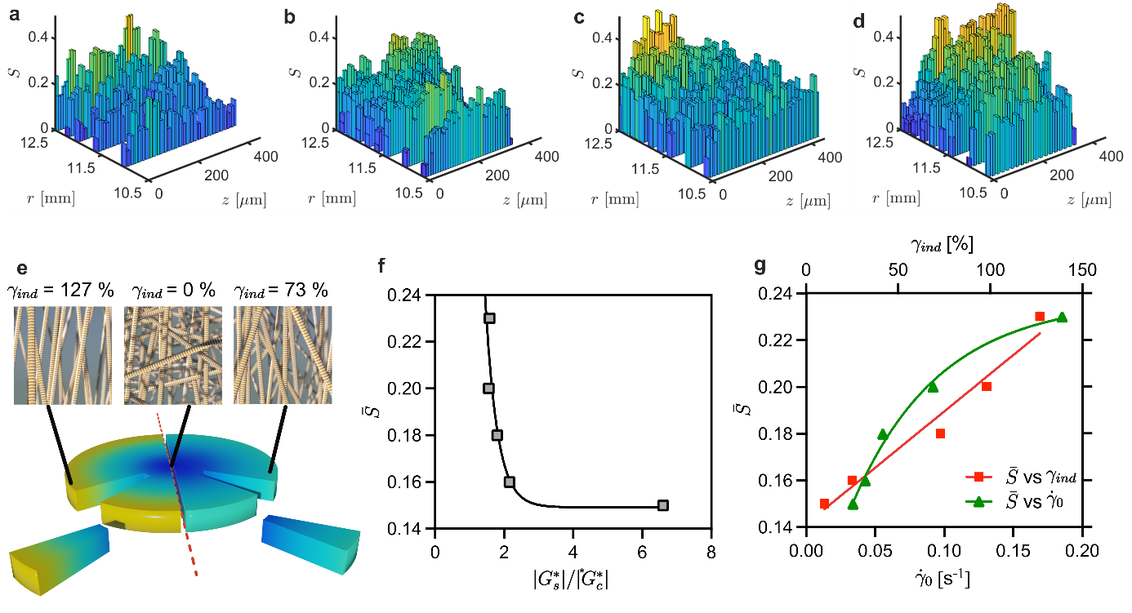

**Figure 5.** **Controlling the macroscopic rheological properties through allows control over the average collagen fiber ordering ().** (a-d) 3D distribution of the resulting order parameter for various initiation points (). The corresponding values are (a) 2.15, (b) 1.80, (c) 1.56 and (d) 1.57. (e) Illustration of the order distribution along the radial direction of the sample for two induced strains (). The color scale in (a-d) represents the magnitude of , also illustrated in (e). (f) Influence of on . (g) Relation between and the induced strain () and the shear flow magnitude (), indicated in red and green respectively. The solid lines in (f) and (g) are plotted to guide the eye. Error bars representing the standard error are smaller than the symbol size in (f) and (g). The applied rotational stress for all these samples was 1.5 Pa. All samples were solidified at a temperature of 27 ◦C.

**3.3 Limits of the stress-controlled procedure**

While control over the alignment was obtained by varying , this was only possible within a certain range. For instance, when a of 1.09 was used, the fibrillar structures broke, meaning that . This is apparent from the steady increase of strain through time after applying the stress (**Figure 6.a**). Under such conditions, the system experiences a continuous flow during gelation, which results in a heterogeneous network of partially formed collagen fiber clusters (**Figure 6.e**). This behavior is similar to the inhomogeneities that occur when applying a constant strain rate to the system (**Figure S6**) [40][41].

When was increased to 1.11, the strain profile initially stabilized before increasing again, implying that the structure fragmented (**Figure 6.b**). Afterwards, the system was allowed to recover, by removing when the strain reached 1000 %, allowing the remaining network to develop in the absence of flow (comparable to applying a constant strain of 1000 %). The resulting structure only showed regions of significant alignment close to the rotating surface (**Figure S7.f**). The corresponding network morphology consisted of inhomogeneous fiber densities over larger scales (**Figure 6.f**). Thereby, one can conclude that the top layer ( 50 m) of the system was fractured when the stress was applied. This behavior indicates that applying a constant strain to the material (instead of a constant stress) results in inhomogeneous alignment in 3D gels.

On the other hand, in the extreme case where the stress was applied after reached its steady-state value ( 65 min), insignificant deformation ( 2.5 %) was observed. Furthermore, this deformation became negligible when the stress was removed (**Figure 6.d**). Consequently, the network morphology remained unchanged compared to quiescent samples (**Figure 6.h**). This means that under such conditions, maintaining the alignment requires the continuous application of external stress, which is not practical. Only for values between these two extreme cases, significant deformation can be obtained in a reproducible fashion while preserving the structural integrity of the system (**Figure 6.c**).

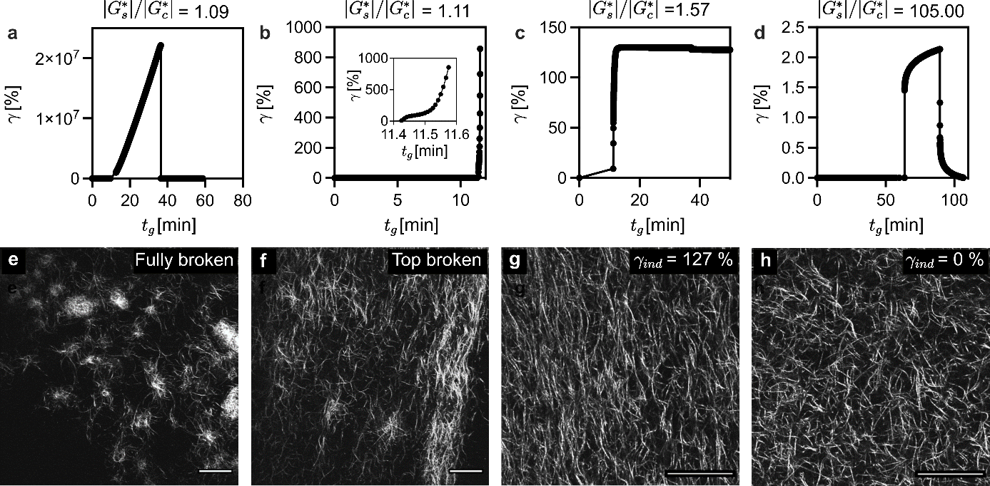

**Figure 6.** **Effect of the initiation point () on the induced microstructure.** (a-d) Rheological strain profiles and (e-h) visualized network morphologies using SHG microscopy. (a and b) Breaking of collagen structure upon applying rotational stress with (e and f) the resulting network morphology of the ruptured structures, respectively. (c) Appropriately chosen results in a significant induced strain (), and (g) the corresponding aligned network. (d) Applying stress after gelation has completed does not result in a significant after stress removal, (h) corresponding to a randomly oriented network. All displayed data are from samples formed at 27 ◦C, subjected to a rotational stress of 1.5 Pa. All scale bars indicate 50 m.

**3.4 Impact of two different gelation temperatures**

To investigate the influence of the solidification temperature on the induced alignment, the same alignment procedure was conducted at 37 ◦C in addition to the previously discussed experiments at 27 ◦C. As mentioned above, for samples solidified at 37 ◦C, an applied stress value of 3.0 Pa was determined to be optimal, all other processing parameters being identical to the 27 ◦C samples. Most notable is the difference observed in the relation between and stiffness () (**Figure 7.a**) as a function of temperature. Samples solidifying at 37 ◦C showed a clear effective strain-hardening behavior (*i.e.*, apositive correlation between stiffness and ), while at 27 ◦C, strain-softening occurred (*i.e.*, a negative correlation between stiffness and ) in addition to an overall higher modulus. Secondly, looking at the strain-ordering profiles (**Figure 7.b**), it is clear that systems solidifying at lower temperatures show significantly higher order than the ones exposed to the physiological 37 ◦C for the same magnitude of . Furthermore, the network morphology obtained differs between the two conditions, with thicker fiber bundles when the network forms at a lower temperature (**Figure 7.c** and **d**). An extra benefit to performing the procedure at temperatures below 37 ◦C is that in some cases increased cell survival can be obtained [46].

The data suggests that the temperature dependence of the gelation kinetics also plays an important role in obtaining highly aligned materials (**Figure 7**). To the best of our knowledge, such discrepancies in both micro- as well as macroscopic material behavior, and respectively, are not described in literature. This highlights the need for further studies in order to gain full understanding of the complex interplay between environmental parameters and stress-controlled alignment in fibrillar hydrogels.

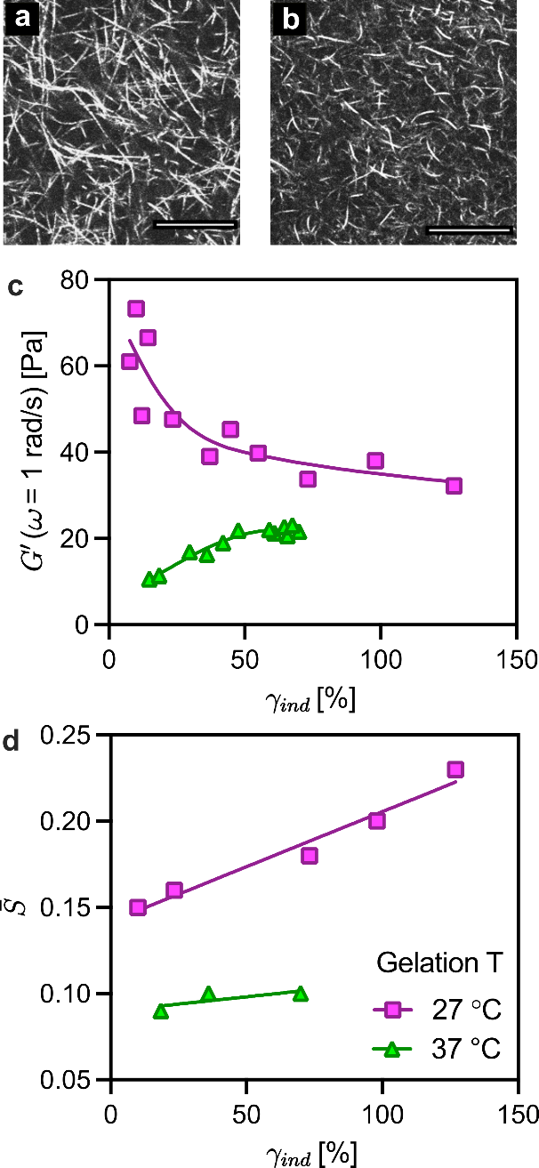

**Figure 7.** **Varying the solidification temperature causes micro- and macroscopic differences in material behavior.** (a and b) Fully formed random network, solidified respectively at 37 ◦C and 27 ◦C. Scale bars are 50 m. (c) Deformation – stiffness relationship comparison for different gelation conditions. (d) Relation between the induced strain and the measured average ordering (). The solid lines are added for visualization. Error bars representing the standard error are smaller than the symbol size in (c) and (d).

**3.5 Cell inclusion**

Finally, since one of the purposes of aligning fibrillar scaffolds is to influence cellular phenotype, we have evaluated the effect of the protocol on the viability of SH-SY5Y neuron-like cell lines. No statistically significant difference ( 0.91 after two hours and 0.10 after 24 hours) was observed between the viability of cells under control (= 0 Pa) and stressed conditions (= 1.5 Pa), at 27 ◦C, measured directly and one day after shearing (**Figure S8**), indicating that the proposed approach does not significantly affect cell viability and is thus compatible with 3D cell incorporation.

Furthermore, we qualitatively show neurite polarization of SH-SY5Y cells (**Figure 8**) three days after inclusion in an aligned sample ( = 73.0 %). This highlights the potential of our technique for future cell guidance studies.

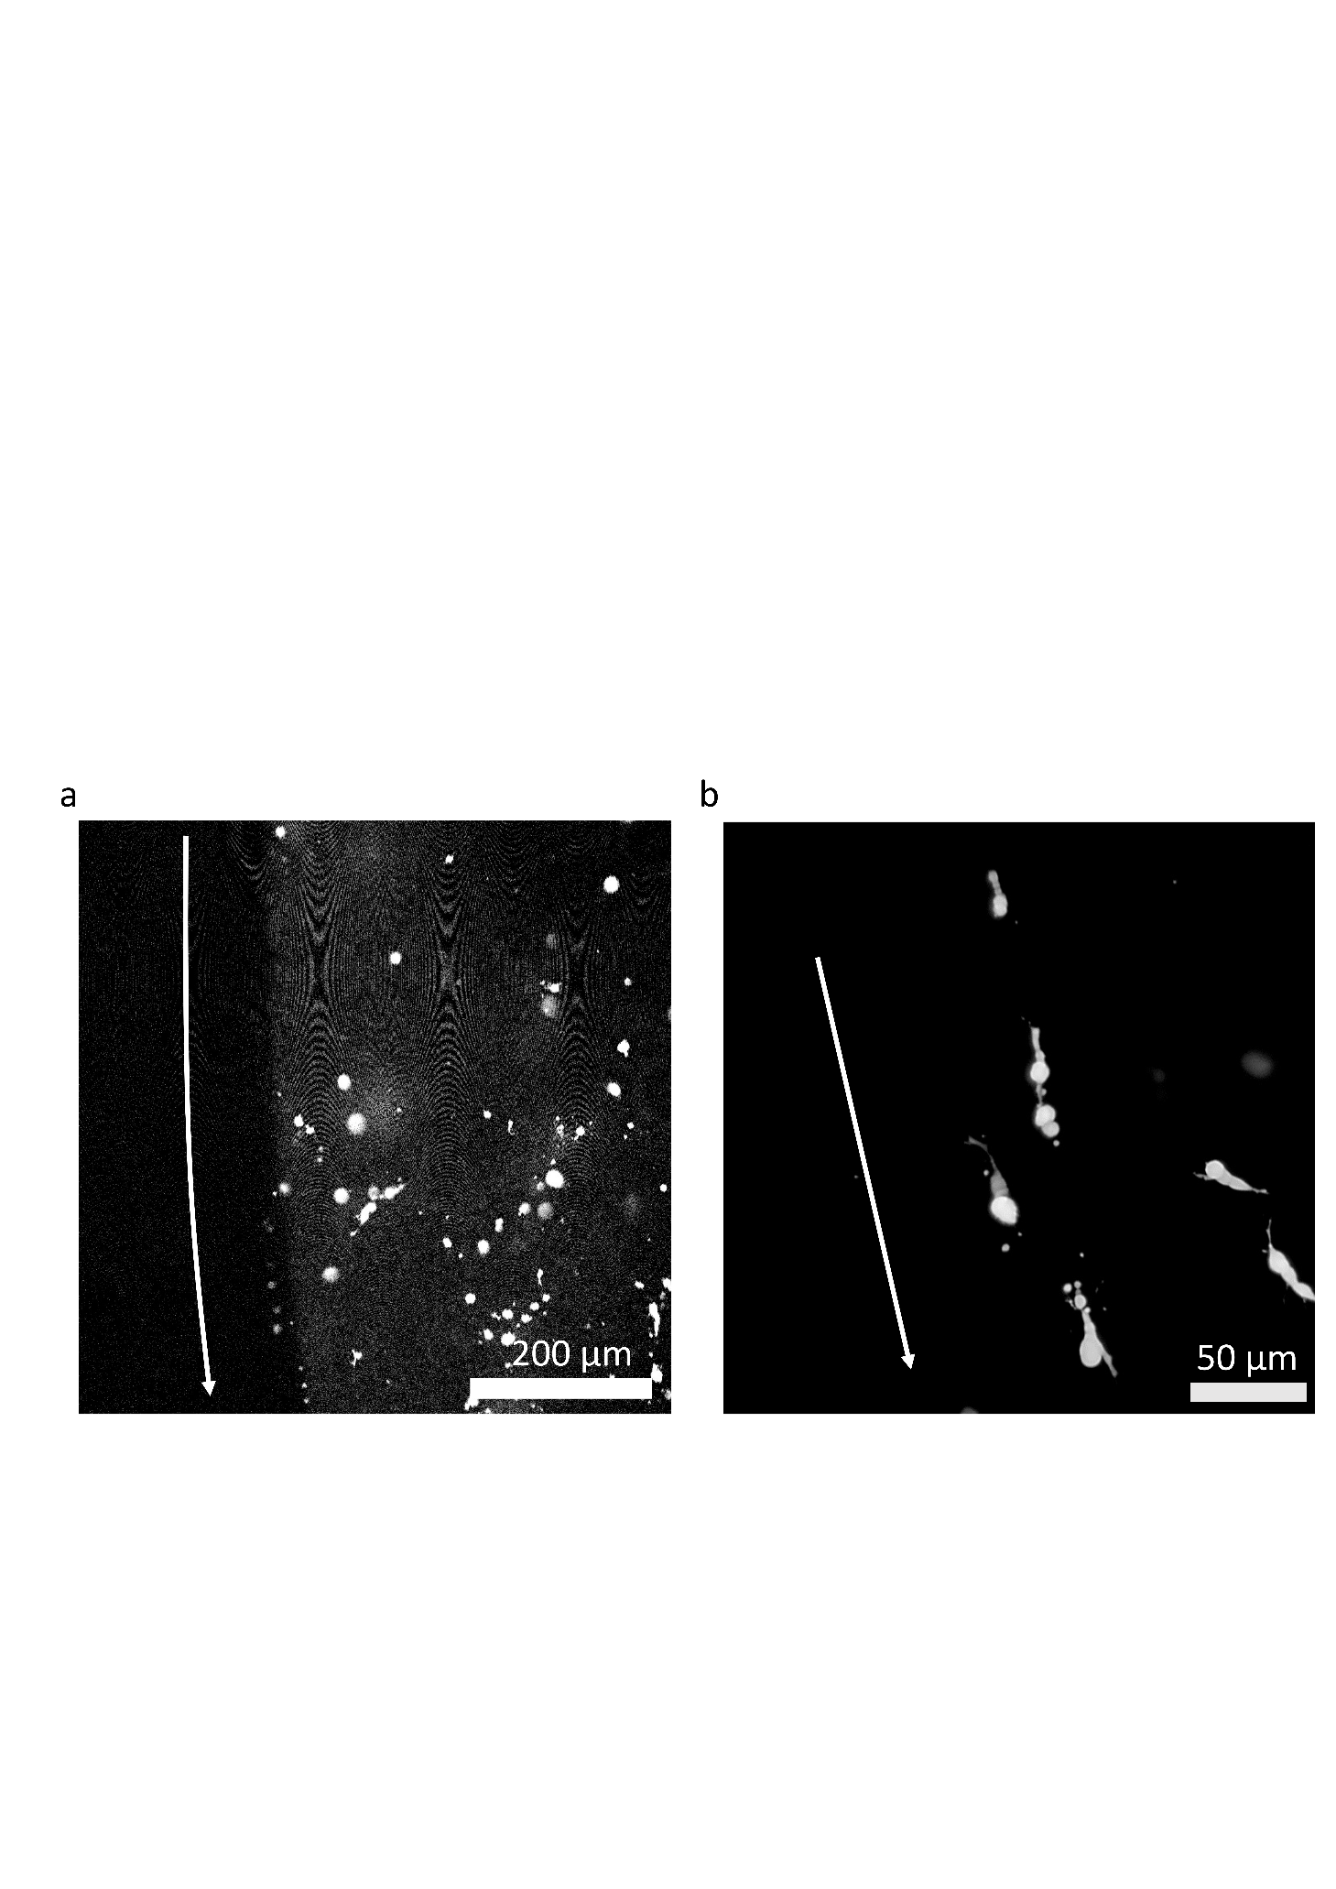

**Figure 8:** **SH-SY5Y polarization in 3D aligned samples.** (a) The azimuth direction (white arrow) of the cylindrical sample is determined based on the visualization of the edge through collagen autofluorescence. (b) Projected confocal Z-stack of GFP-tagged SH-SY5Y three days after sample fabrication. The white arrow indicates the local collagen fiber orientation (azimuth direction). Conditions used to obtain this sample were = 1.5 Pa, = 1.78 and a solidification temperature of 27◦C, resulting in an induced strain of 73.0 %.

**3.6 Outlook**

Our protocol offers a high degree of reproducibility and tunability over alignment in 3D cell containing hydrogels, without the need for indefinitely maintaining external stresses on the system. The new method is a first step towards understanding the features needed for commercial production of 3D anisotropic materials, which could for example be achieved if the knowledge acquired in this study is translated to extrusion approaches.Furthermore, because of its reproducibility, our technique allows to systematically evaluate the link between process parameters and the resulting alignment. Among the relevant process parameters are: pH, temperature, monomer concentration, humidity, etc. Variations in this parameter space may induce changes in the phenotype of embedded cells, allowing to better understand the role of alignment in living matter, and perfect industrial biotechnological processes.

We also note that this approach is not limited to collagen type-I, but can be applied to all materials developing a fibrillar hydrogel structure over time, both natural (*e.g.,* other collagen types, fibronectin, fibrin etc.) and synthetic. Of special interest are the animal-free synthetic alternatives, which have higher availability, batch to batch reproducibility and lower chance of pathogen contamination. Some interesting candidates are block copolymer worm-like micelles, peptide and filamentous nanoparticle hydrogels composed of cellulose or chitin nanocrystals.

**4. Conclusions**

In this paper we discuss a shear stress-controlled flow method for the *in vitro* fabrication of 3D aligned fibrillar cell matrices and identify the parameters affecting the collagen fiber ordering. We show that the initiation time at which the stress has to be applied is sample specific and needs to be determined *in situ* by measuring the stiffness of the solidifying sample (*e.g.,* ), rather than by choosing a fixed point in time. Furthermore, a broad range of orientational ordering can be obtained in a controlled manner by varying , which is linearly related to the induced strain . Lastly, the effect of the different solidifying temperatures on the system hints at a complex interplay between gelation kinetics, structure morphology, and susceptibility to shear induced alignment. These observations aid the development of a biocompatible shear flow method capable of inducing homogeneous ordering in bulk cell-laden 3D fibrillar hydrogels, with a reproducibility surpassing that of the current state of the art protocols. While previous approaches described alignment and its effect on cells as a binary concept (with or without alignment), the reproducibility of the new stress-controlled method provides a reliable handle to fine tune alignment and systematically investigate its effect on living cells. This opens up possibilities for further studies focusing on the link between cellular phenotype and 3D anisotropy over well-defined ranges of alignment.

Acknowledgements

L. Dedroog acknowledges the financial support by the Flanders Research Foundation (FWO) – strategic basic research doctoral grant 1S65722N. C. Bartic, P. Lettinga, W. Thielemans and O. Deschaume acknowledge the financial support by the Flanders Research Foundation (Grant no. G0947.17N) and KU Leuven research fund grant no. C14/18/061.

**References**

[1] B.M. Baker, C.S. Chen, Deconstructing the third dimension-how 3D culture microenvironments alter cellular cues, J. Cell Sci. 125 (2012) 3015–3024. https://doi.org/10.1242/jcs.079509.

[2] K. Dzobo, N.E. Thomford, D.A. Senthebane, H. Shipanga, A. Rowe, C. Dandara, M. Pillay, K.S.C.M. Motaung, Advances in regenerative medicine and tissue engineering: Innovation and transformation of medicine, Stem Cells Int. 2018 (2018). https://doi.org/10.1155/2018/2495848.

[3] T.T.K. Vuong-Brender, M. Ben Amar, J. Pontabry, M. Labouesse, The interplay of stiffness and force anisotropies drives embryo elongation, Elife. 6 (2017). https://doi.org/10.7554/eLife.23866.

[4] X. Wang, M. Merkel, L.B. Sutter, G. Erdemci-Tandogan, M.L. Manning, K.E. Kasza, Anisotropy links cell shapes to tissue flow during convergent extension, Proc. Natl. Acad. Sci. U. S. A. 117 (2020) 13541–13551. https://doi.org/10.1073/pnas.1916418117.

[5] C.J.G. Abrego, L. Dedroog, O. Deschaume, J. Wellens, A. Vananroye, M.P. Lettinga, J. Patterson, C. Bartic, Multiscale Characterization of the Mechanical Properties of Fibrin and Polyethylene Glycol (PEG) Hydrogels for Tissue Engineering Applications, Macromol. Chem. Phys. (2021) 2100366. https://doi.org/10.1002/macp.202100366.

[6] K. Esbona, Y. Yi, S. Saha, M. Yu, R.R. Van Doorn, M.W. Conklin, D.S. Graham, K.B. Wisinski, S.M. Ponik, K.W. Eliceiri, L.G. Wilke, P.J. Keely, The Presence of Cyclooxygenase 2, Tumor-Associated Macrophages, and Collagen Alignment as Prognostic Markers for Invasive Breast Carcinoma Patients, Am. J. Pathol. 188 (2018) 559–573. https://doi.org/10.1016/j.ajpath.2017.10.025.

[7] M.W. Conklin, R.E. Gangnon, B.L. Sprague, L. Van Gemert, J.M. Hampton, K.W. Eliceiri, J.S. Bredfeldt, Y. Liu, N. Surachaicharn, P.A. Newcomb, A. Friedl, P.J. Keely, A. Trentham-Dietz, Collagen alignment as a predictor of recurrence after ductal carcinoma in situ, Cancer Epidemiol. Biomarkers Prev. 27 (2018) 138–145. https://doi.org/10.1158/1055-9965.EPI-17-0720.

[8] A. Ray, Z.M. Slama, R.K. Morford, S.A. Madden, P.P. Provenzano, Enhanced Directional Migration of Cancer Stem Cells in 3D Aligned Collagen Matrices, Biophys. J. 112 (2017) 1023–1036. https://doi.org/10.1016/j.bpj.2017.01.007.

[9] J.K. Mouw, G. Ou, V.M. Weaver, Extracellular matrix assembly: A multiscale deconstruction, Nat. Rev. Mol. Cell Biol. 15 (2014) 771–785. https://doi.org/10.1038/nrm3902.

[10] R. Devolder, H.J. Kong, Hydrogels for in vivo-like three-dimensional cellular studies, Wiley Interdiscip. Rev. Syst. Biol. Med. 4 (2012) 351–365. https://doi.org/10.1002/wsbm.1174.

[11] G. Montalbano, S. Toumpaniari, A. Popov, P. Duan, J. Chen, K. Dalgarno, W.E. Scott, A.M. Ferreira, Synthesis of bioinspired collagen/alginate/fibrin based hydrogels for soft tissue engineering, Mater. Sci. Eng. C. 91 (2018) 236–246. https://doi.org/10.1016/j.msec.2018.04.101.

[12] Y.L. Yang, L.J. Kaufman, Rheology and confocal reflectance microscopy as probes of mechanical properties and structure during collagen and collagen/hyaluronan self-assembly, Biophys. J. 96 (2009) 1566–1585. https://doi.org/10.1016/j.bpj.2008.10.063.

[13] G. Cox, E. Kable, A. Jones, I. Fraser, F. Manconi, M.D. Gorrell, 3-Dimensional imaging of collagen using second harmonic generation, J. Struct. Biol. 141 (2003) 53–62. https://doi.org/10.1016/S1047-8477(02)00576-2.

[14] J.H. Lee, S. Lee, C.J. Yoon, J.H. Park, H. Tchah, M.J. Kim, K.H. Kim, Comparison of reflectance confocal microscopy and two-photon second harmonic generation microscopy in fungal keratitis rabbit model ex vivo, Biomed. Opt. Express. 7 (2016) 677. https://doi.org/10.1364/BOE.7.000677.

[15] E. Hase, T. Yasui, Orientation analysis of collagen fibers in skin by using polarization-resolved second-harmonic generation microscopy, https://doi.org/10.1117/12.2613415. PC11934 (2022) PC1193408. https://doi.org/10.1117/12.2613415.

[16] Y.S. Zhang, J. Aleman, A. Arneri, S. Bersini, F. Piraino, S.R. Shin, M.R. Dokmeci, A. Khademhosseini, From cardiac tissue engineering to heart-on-a-chip: Beating challenges, Biomed. Mater. 10 (2015). https://doi.org/10.1088/1748-6041/10/3/034006.

[17] A.R. Gillies, R.L. Lieber, Structure and function of the skeletal muscle extracellular matrix, Muscle and Nerve. 44 (2011) 318–331. https://doi.org/10.1002/mus.22094.

[18] Z. Y., D. Garciadiego-Czares, C. Parra- Cid, R. Aguilar-Gaytn, C. Velasquillo, C. Ibarra, J.S. Castro Carmo, Cartilage Tissue Engineering: The Role of Extracellular Matrix (ECM) and Novel Strategies, in: Regen. Med. Tissue Eng., IntechOpen, 2013. https://doi.org/10.5772/55917.

[19] J.F. Ribeiro, E.H.M. dos Anjos, M.L.S. Mello, B. de Campos Vidal, Skin Collagen Fiber Molecular Order: A Pattern of Distributional Fiber Orientation as Assessed by Optical Anisotropy and Image Analysis, PLoS One. 8 (2013). https://doi.org/10.1371/journal.pone.0054724.

[20] J. Foolen, S.L. Wunderli, S. Loerakker, J.G. Snedeker, Tissue alignment enhances remodeling potential of tendon-derived cells - Lessons from a novel microtissue model of tendon scarring, Matrix Biol. 65 (2018) 14–29. https://doi.org/10.1016/j.matbio.2017.06.002.

[21] P. Camelliti, J.O. Gallagher, P. Kohl, A.D. McCulloch, Micropatterned cell cultures on elastic membranes as an in vitro model of myocardium, Nat. Protoc. 1 (2006) 1379–1391. https://doi.org/10.1038/nprot.2006.203.

[22] C. Simitzi, P. Efstathopoulos, A. Kourgiantaki, A. Ranella, I. Charalampopoulos, C. Fotakis, I. Athanassakis, E. Stratakis, A. Gravanis, Laser fabricated discontinuous anisotropic microconical substrates as a new model scaffold to control the directionality of neuronal network outgrowth, Biomaterials. 67 (2015) 115–128. https://doi.org/10.1016/j.biomaterials.2015.07.008.

[23] R. Ozasa, A. Matsugaki, Y. Isobe, T. Saku, H.S. Yun, T. Nakano, Construction of human induced pluripotent stem cell-derived oriented bone matrix microstructure by using in vitro engineered anisotropic culture model, J. Biomed. Mater. Res. - Part A. 106 (2018) 360–369. https://doi.org/10.1002/jbm.a.36238.

[24] T.J. Puls, X. Tan, M. Husain, C.F. Whittington, M.L. Fishel, S.L. Voytik-Harbin, Development of a Novel 3D Tumor-tissue Invasion Model for High-throughput, High-content Phenotypic Drug Screening, Sci. Rep. 8 (2018). https://doi.org/10.1038/s41598-018-31138-6.

[25] C. O’Rourke, R. Drake, J. Loughlin, J. Phillips, Adapting aligned stabilised hydrogels to facilitate large scale drug screening and neurobiological research., Mater. Sci. (2013).

[26] H. Aubin, J.W. Nichol, C.B. Hutson, H. Bae, A.L. Sieminski, D.M. Cropek, P. Akhyari, A. Khademhosseini, Directed 3D cell alignment and elongation in microengineered hydrogels, Biomaterials. 31 (2010) 6941–6951. https://doi.org/10.1016/j.biomaterials.2010.05.056.

[27] O. V. Cangellaris, M.U. Gillette, Biomaterials for enhancing neuronal repair, Front. Mater. 5 (2018) 21. https://doi.org/10.3389/fmats.2018.00021.

[28] T. Namba, Y. Funahashi, S. Nakamuta, C. Xu, T. Takano, K. Kaibuchi, Extracellular and intracellular signaling for neuronal polarity, Physiol. Rev. 95 (2015) 995–1024. https://doi.org/10.1152/physrev.00025.2014.

[29] A. Ahmed, I.M. Joshi, M. Mansouri, N.N.N. Ahamed, M.C. Hsu, T.R. Gaborski, V. V. Abhyankar, Engineering fiber anisotropy within natural collagen hydrogels, Am. J. Physiol. - Cell Physiol. 320 (2021) C1112–C1124. https://doi.org/10.1152/AJPCELL.00036.2021.

[30] A. Omidinia-Anarkoli, S. Boesveld, U. Tuvshindorj, J.C. Rose, T. Haraszti, L. De Laporte, An Injectable Hybrid Hydrogel with Oriented Short Fibers Induces Unidirectional Growth of Functional Nerve Cells, Small. 13 (2017). https://doi.org/10.1002/smll.201702207.

[31] B.A. Nerger, P.T. Brun, C.M. Nelson, Marangoni flows drive the alignment of fibrillar cell-laden hydrogels, Sci. Adv. 6 (2020) 7748–7760. https://doi.org/10.1126/sciadv.aaz7748.

[32] B.A. Nerger, P.T. Brun, C.M. Nelson, Microextrusion printing cell-laden networks of type i collagen with patterned fiber alignment and geometry, Soft Matter. 15 (2019) 5728–5738. https://doi.org/10.1039/c8sm02605j.

[33] A. Schwab, C. Hélary, R.G. Richards, M. Alini, D. Eglin, M. D’Este, Tissue mimetic hyaluronan bioink containing collagen fibers with controlled orientation modulating cell migration and alignment, Mater. Today Bio. 7 (2020). https://doi.org/10.1016/j.mtbio.2020.100058.

[34] H. Kim, J. Jang, J. Park, K.P. Lee, S. Lee, D.M. Lee, K.H. Kim, H.K. Kim, D.W. Cho, Shear-induced alignment of collagen fibrils using 3D cell printing for corneal stroma tissue engineering, Biofabrication. 11 (2019). https://doi.org/10.1088/1758-5090/ab1a8b.

[35] M.G. McCoy, J.M. Wei, S. Choi, J.P. Goerger, W. Zipfel, C. Fischbach, Collagen Fiber Orientation Regulates 3D Vascular Network Formation and Alignment, ACS Biomater. Sci. Eng. 4 (2018) 2967–2976. https://doi.org/10.1021/acsbiomaterials.8b00384.

[36] S.H. Kim, S.K. Im, S.J. Oh, S. Jeong, E.S. Yoon, C.J. Lee, N. Choi, E.M. Hur, Anisotropically organized three-dimensional culture platform for reconstruction of a hippocampal neural network, Nat. Commun. 8 (2017). https://doi.org/10.1038/ncomms14346.

[37] P. V. Taufalele, J.A. VanderBurgh, A. Muñoz, M.R. Zanotelli, C.A. Reinhart-King, Fiber alignment drives changes in architectural and mechanical features in collagen matrices, PLoS One. 14 (2019). https://doi.org/10.1371/journal.pone.0216537.

[38] M. Antman-Passig, S. Levy, C. Gartenberg, H. Schori, O. Shefi, Mechanically Oriented 3D Collagen Hydrogel for Directing Neurite Growth, Tissue Eng. Part A. 23 (2017) 403–414. https://doi.org/10.1089/TEN.TEA.2016.0185.

[39] E. Nam, W.C. Lee, S. Takeuchi, Formation of Highly Aligned Collagen Nanofibers by Continuous Cyclic Stretch of a Collagen Hydrogel Sheet, Macromol. Biosci. 16 (2016) 995–1000. https://doi.org/10.1002/MABI.201600068.

[40] S. Lin-Gibson, J.A. Pathak, E.A. Grulke, H. Wang, E.K. Hobbie, Elastic Flow Instability in Nanotube Suspensions, Phys. Rev. Lett. 92 (2004) 4. https://doi.org/10.1103/PhysRevLett.92.048302.

[41] M. Das, L. Chambon, Z. Varga, M. Vamvakaki, J.W. Swan, G. Petekidis, Shear driven vorticity aligned flocs in a suspension of attractive rigid rods, Soft Matter. 17 (2021) 1232–1245. https://doi.org/10.1039/d0sm01576h.

[42] R.C. Arevalo, P. Kumar, J.S. Urbach, D.L. Blair, Stress heterogeneities in sheared type-i collagen networks revealed by boundary stress microscopy, PLoS One. 10 (2015). https://doi.org/10.1371/journal.pone.0118021.

[43] A. Sharma, A.J. Licup, K.A. Jansen, R. Rens, M. Sheinman, G.H. Koenderink, F.C. Mackintosh, Strain-controlled criticality governs the nonlinear mechanics of fibre networks, Nat. Phys. 12 (2016) 584–587. https://doi.org/10.1038/nphys3628.

[44] D.J. Steinberg, Equation of state and strength properties of selected materials, Lawrence Livermore National Laboratory report, 1996. https://www.worldcat.org/title/equation-of-state-and-strength-properties-of-selected-materials/oclc/54089938 (accessed July 5, 2021).

[45] K.R. Purdy, Z. Dogic, S. Fraden, A. Rühm, L. Lurio, S.G.J. Mochrie, Measuring the nematic order of suspensions of colloidal fd virus by x-ray diffraction and optical birefringence, Phys. Rev. E - Stat. Physics, Plasmas, Fluids, Relat. Interdiscip. Top. 67 (2003) 12. https://doi.org/10.1103/PhysRevE.67.031708.

[46] K. Sakaguchi, Y. Hinata, Y. Kagawa, K. Iwasaki, S. Tsuneda, T. Shimizu, M. Umezu, Low-temperature culturing improves survival rate of tissue-engineered cardiac cell sheets, Biochem. Biophys. Reports. 14 (2018) 89–97. https://doi.org/10.1016/j.bbrep.2018.04.001.